flash memory simulation

THZOE is 7nsec
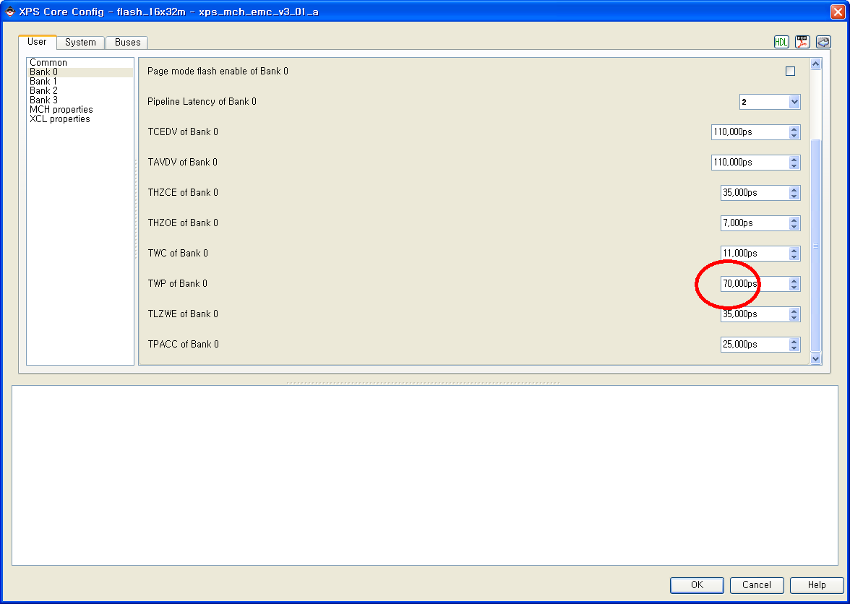

Write mode, 1clk, 12clk, 4clk
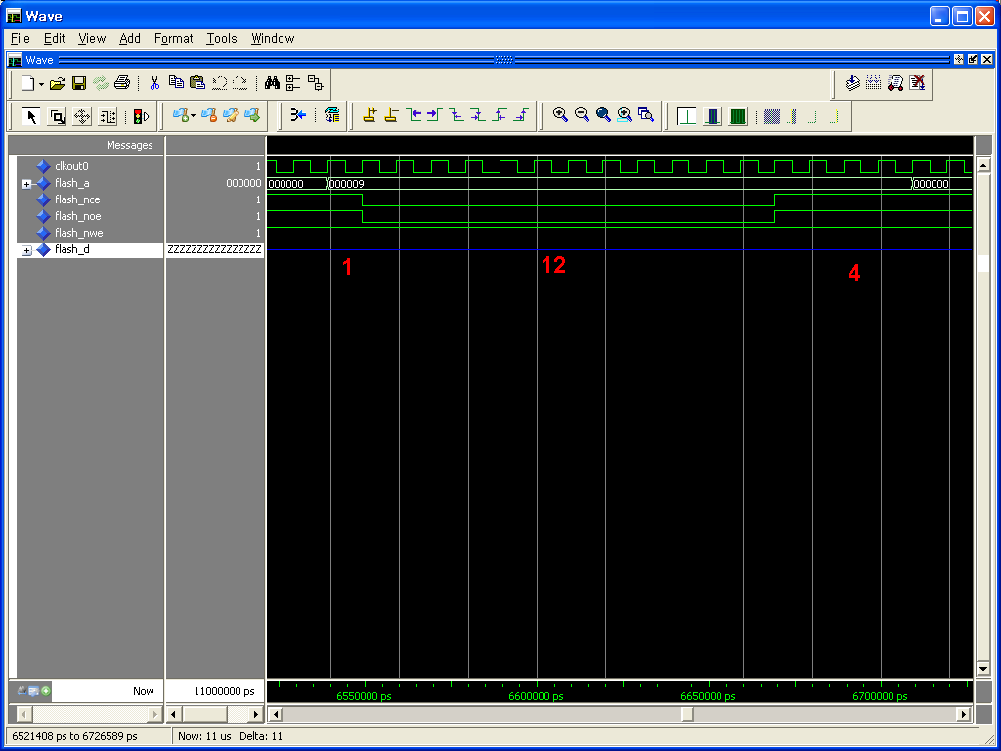

Read mode, 1 clk, 8clk, 1clk
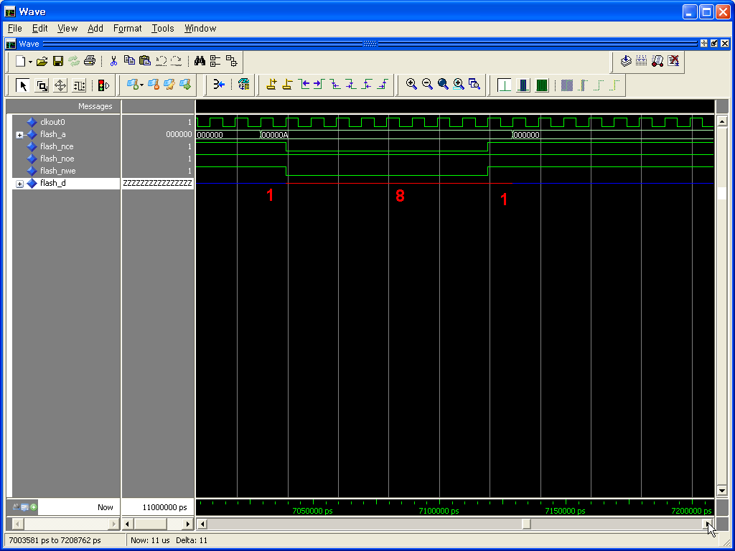

Change THZOE from 7nsec to 25nsec
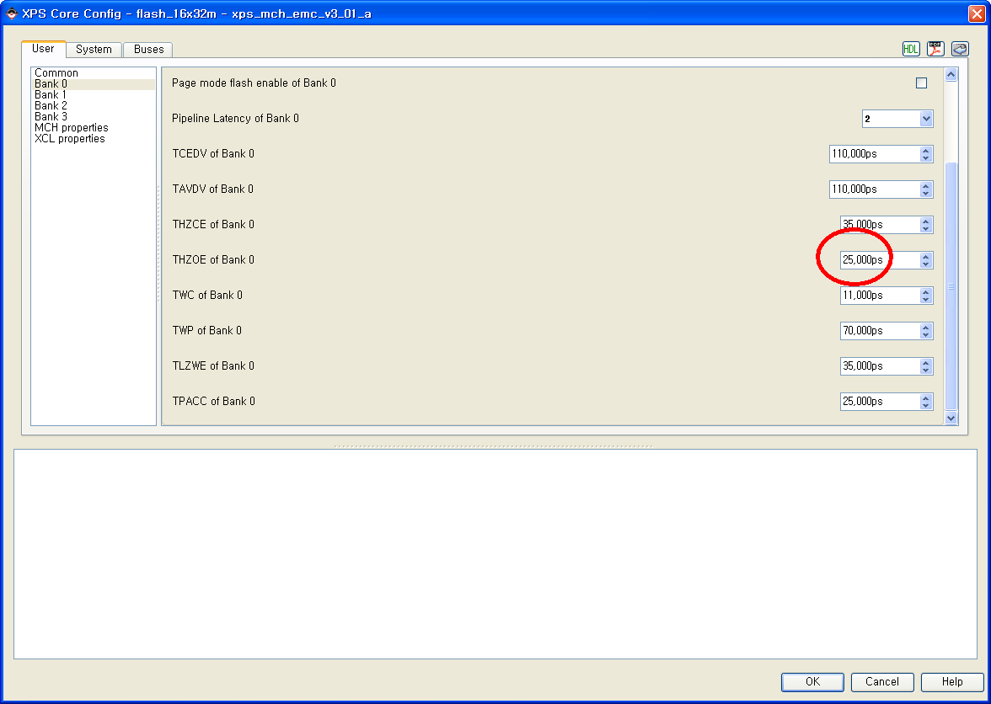

Write mode, 1clk, 12clk, 4clk
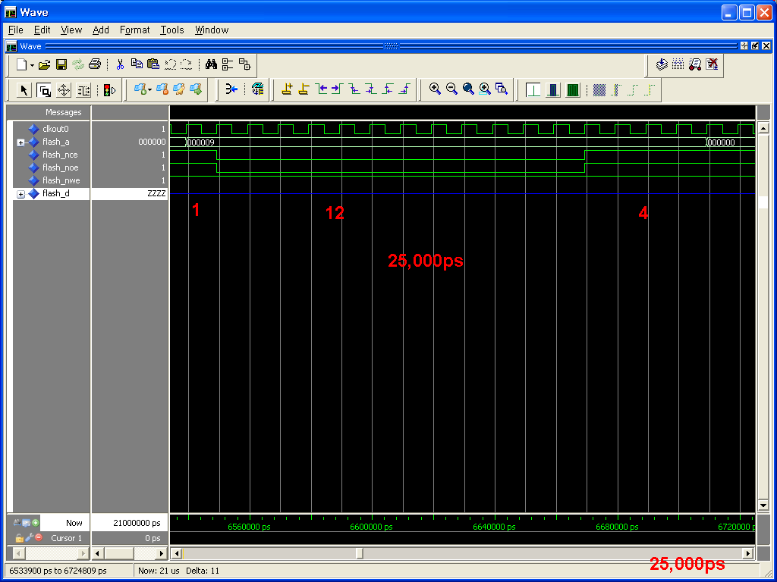

Read mode, 1clk, 8clk, 1clk
