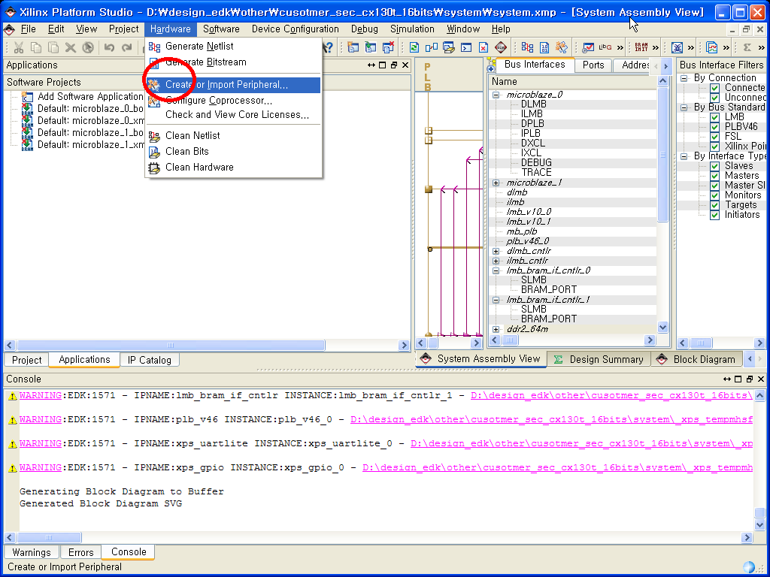
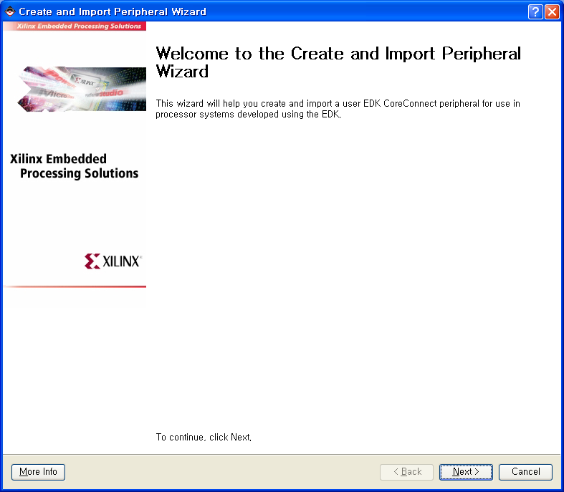
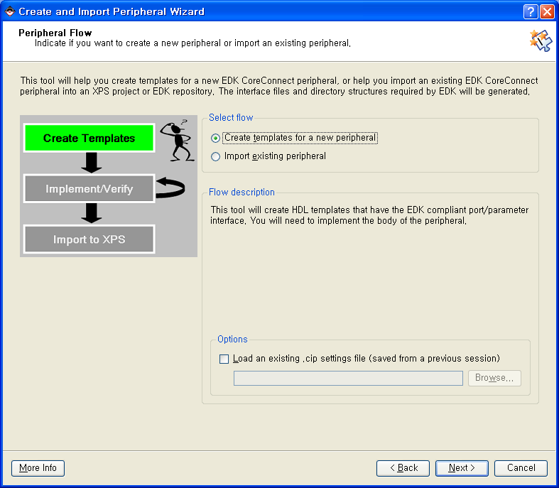
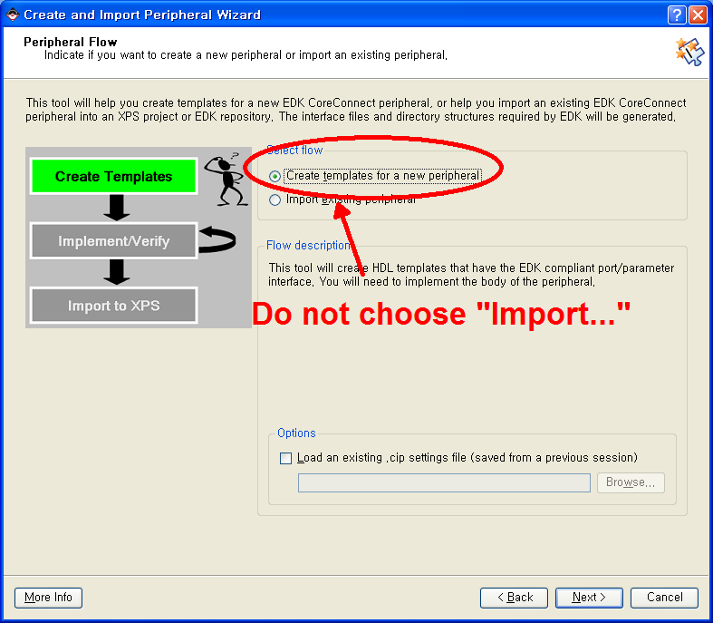
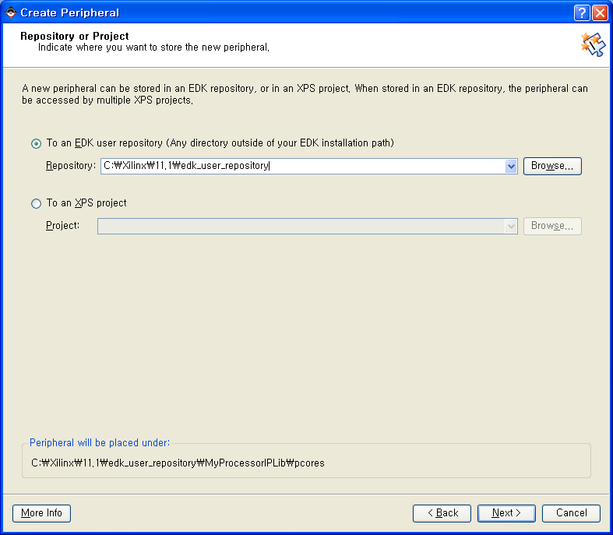
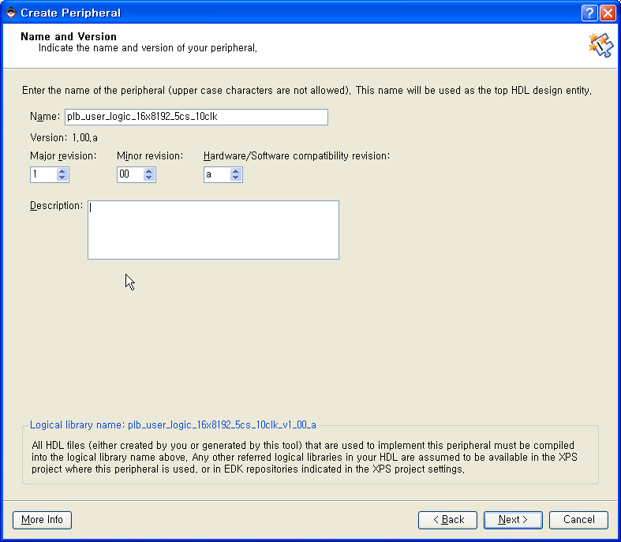
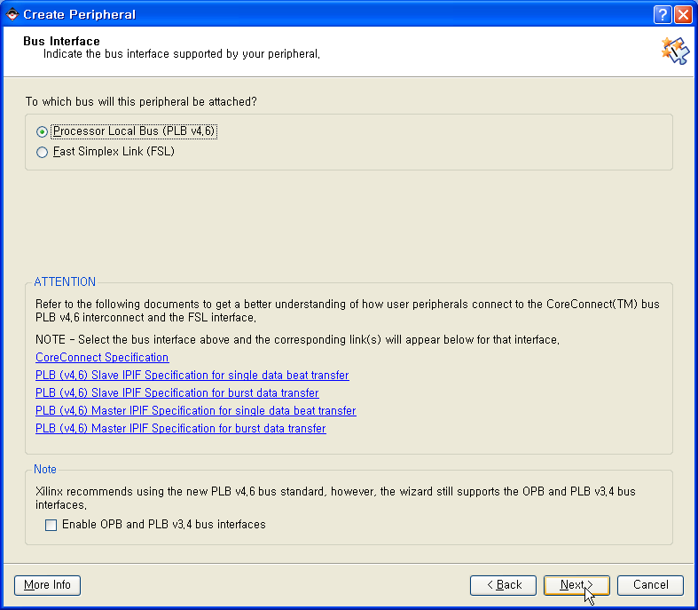

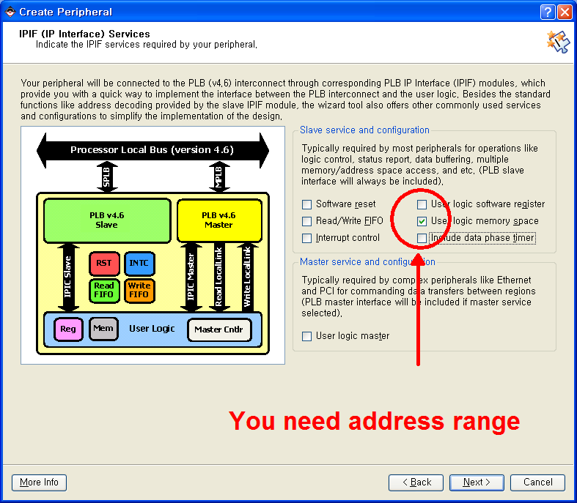

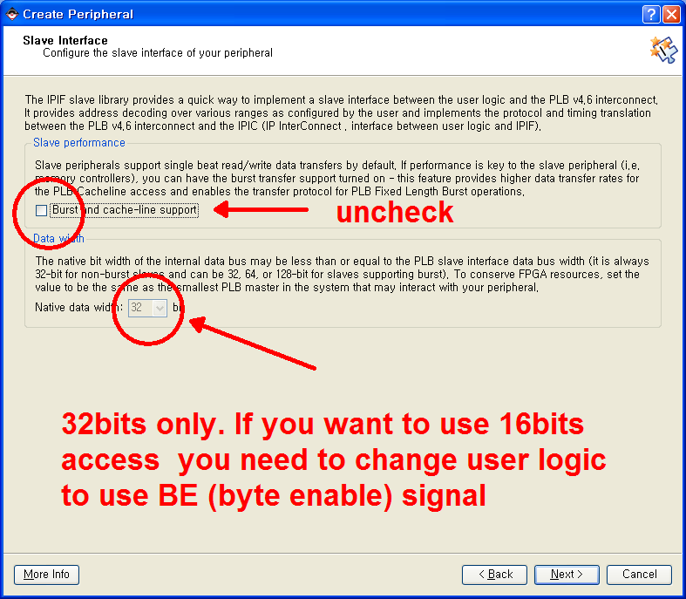
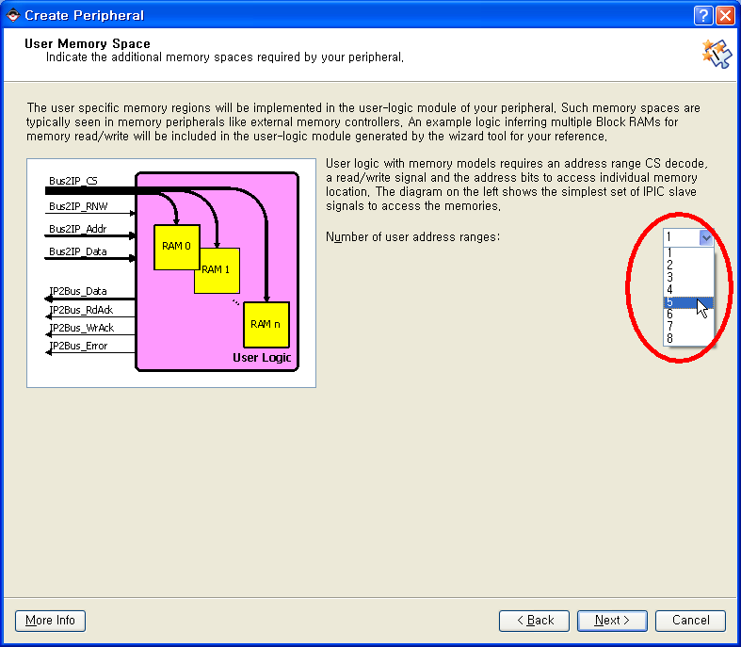
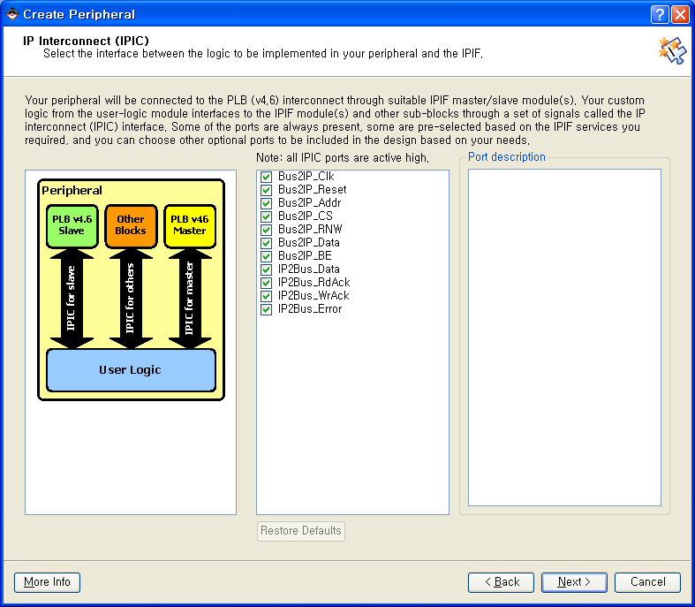
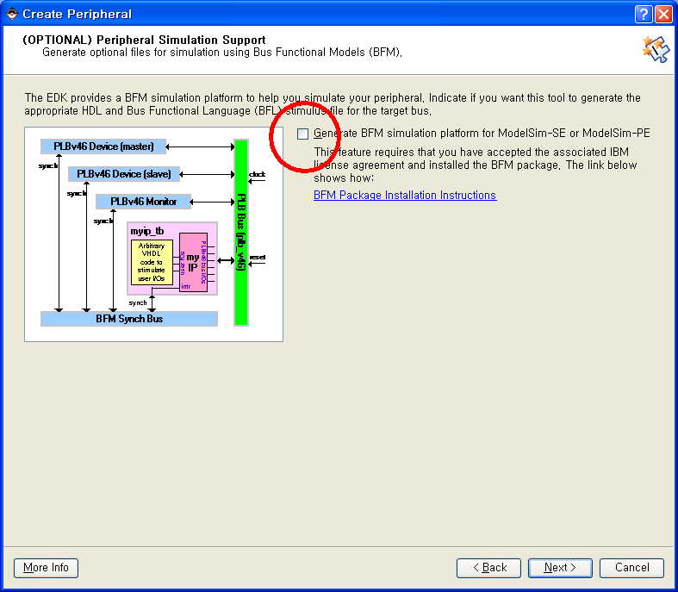
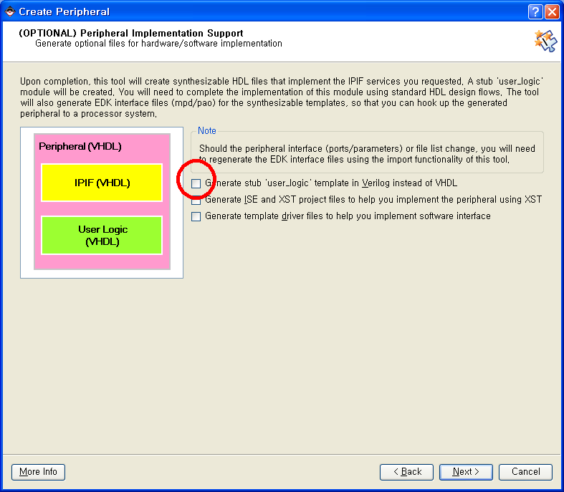

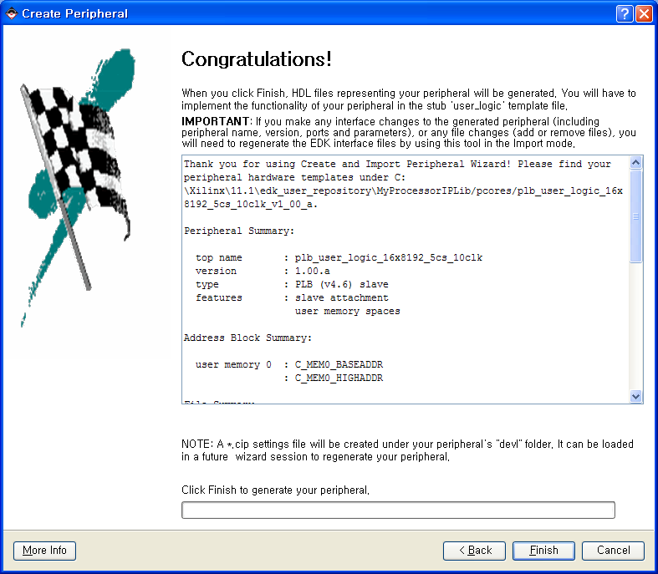

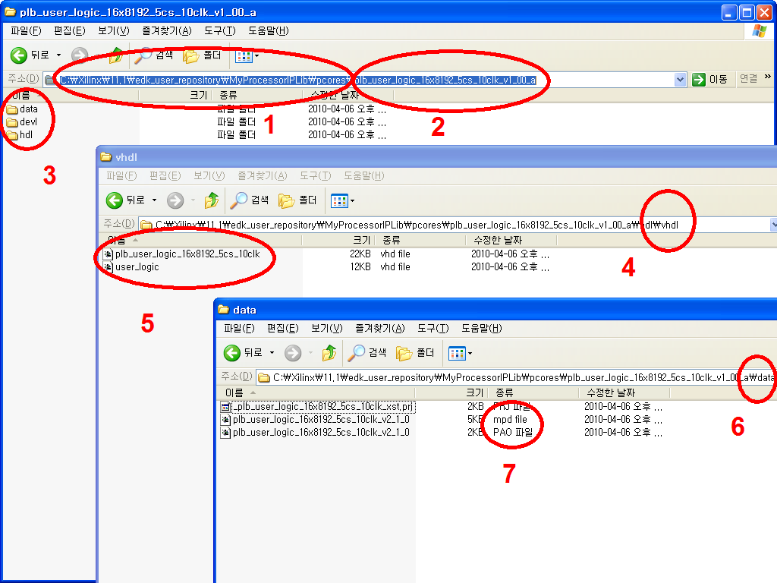

C:\Xilinx\11.1\edk_user_repository\MyProcessorIPLib\pcores\plb_user_logic_16x8192_5cs_10clk_v1_00_a\data

------------------------------------------------------------------------------
-- user_logic.vhd - entity/architecture pair
------------------------------------------------------------------------------
--
-- ***************************************************************************
-- ** Copyright (c) 1995-2009 Xilinx, Inc. All rights reserved. **
-- ** **
-- ** Xilinx, Inc. **
-- ** XILINX IS PROVIDING THIS DESIGN, CODE, OR INFORMATION "AS IS" **
-- ** AS A COURTESY TO YOU, SOLELY FOR USE IN DEVELOPING PROGRAMS AND **
-- ** SOLUTIONS FOR XILINX DEVICES. BY PROVIDING THIS DESIGN, CODE, **
-- ** OR INFORMATION AS ONE POSSIBLE IMPLEMENTATION OF THIS FEATURE, **
-- ** APPLICATION OR STANDARD, XILINX IS MAKING NO REPRESENTATION **
-- ** THAT THIS IMPLEMENTATION IS FREE FROM ANY CLAIMS OF INFRINGEMENT, **
-- ** AND YOU ARE RESPONSIBLE FOR OBTAINING ANY RIGHTS YOU MAY REQUIRE **
-- ** FOR YOUR IMPLEMENTATION. XILINX EXPRESSLY DISCLAIMS ANY **
-- ** WARRANTY WHATSOEVER WITH RESPECT TO THE ADEQUACY OF THE **
-- ** IMPLEMENTATION, INCLUDING BUT NOT LIMITED TO ANY WARRANTIES OR **
-- ** REPRESENTATIONS THAT THIS IMPLEMENTATION IS FREE FROM CLAIMS OF **
-- ** INFRINGEMENT, IMPLIED WARRANTIES OF MERCHANTABILITY AND FITNESS **
-- ** FOR A PARTICULAR PURPOSE. **
-- ** **
-- ***************************************************************************
--
------------------------------------------------------------------------------
-- Filename: user_logic.vhd
-- Version: 1.00.a
-- Description: User logic.
-- Date: Tue Apr 06 13:46:31 2010 (by Create and Import Peripheral Wizard)
-- VHDL Standard: VHDL'93
------------------------------------------------------------------------------
-- Naming Conventions:
-- active low signals: "*_n"
-- clock signals: "clk", "clk_div#", "clk_#x"
-- reset signals: "rst", "rst_n"
-- generics: "C_*"
-- user defined types: "*_TYPE"
-- state machine next state: "*_ns"
-- state machine current state: "*_cs"
-- combinatorial signals: "*_com"
-- pipelined or register delay signals: "*_d#"
-- counter signals: "*cnt*"
-- clock enable signals: "*_ce"
-- internal version of output port: "*_i"
-- device pins: "*_pin"
-- ports: "- Names begin with Uppercase"
-- processes: "*_PROCESS"
-- component instantiations: "<ENTITY_>I_<#|FUNC>"
------------------------------------------------------------------------------

-- DO NOT EDIT BELOW THIS LINE --------------------
library ieee;
use ieee.std_logic_1164.all;
use ieee.std_logic_arith.all;
use ieee.std_logic_unsigned.all;

library proc_common_v3_00_a;
use proc_common_v3_00_a.proc_common_pkg.all;

-- DO NOT EDIT ABOVE THIS LINE --------------------

--USER libraries added here

------------------------------------------------------------------------------
-- Entity section
------------------------------------------------------------------------------
-- Definition of Generics:
-- C_SLV_AWIDTH -- Slave interface address bus width
-- C_SLV_DWIDTH -- Slave interface data bus width
-- C_NUM_MEM -- Number of memory spaces
--
-- Definition of Ports:
-- Bus2IP_Clk -- Bus to IP clock
-- Bus2IP_Reset -- Bus to IP reset
-- Bus2IP_Addr -- Bus to IP address bus
-- Bus2IP_CS -- Bus to IP chip select for user logic memory selection
-- Bus2IP_RNW -- Bus to IP read/not write
-- Bus2IP_Data -- Bus to IP data bus
-- Bus2IP_BE -- Bus to IP byte enables
-- IP2Bus_Data -- IP to Bus data bus
-- IP2Bus_RdAck -- IP to Bus read transfer acknowledgement
-- IP2Bus_WrAck -- IP to Bus write transfer acknowledgement
-- IP2Bus_Error -- IP to Bus error response
------------------------------------------------------------------------------

entity user_logic is
generic
(
-- ADD USER GENERICS BELOW THIS LINE ---------------
--USER generics added here
-- ADD USER GENERICS ABOVE THIS LINE ---------------

-- DO NOT EDIT BELOW THIS LINE ---------------------
-- Bus protocol parameters, do not add to or delete
C_SLV_AWIDTH : integer := 32;
C_SLV_DWIDTH : integer := 32;
C_NUM_MEM : integer := 1
-- DO NOT EDIT ABOVE THIS LINE ---------------------
);
port
(
-- ADD USER PORTS BELOW THIS LINE ------------------
--USER ports added here
-- ADD USER PORTS ABOVE THIS LINE ------------------

-- DO NOT EDIT BELOW THIS LINE ---------------------
-- Bus protocol ports, do not add to or delete
Bus2IP_Clk : in std_logic;
Bus2IP_Reset : in std_logic;
Bus2IP_Addr : in std_logic_vector(0 to C_SLV_AWIDTH-1);
Bus2IP_CS : in std_logic_vector(0 to C_NUM_MEM-1);
Bus2IP_RNW : in std_logic;
Bus2IP_Data : in std_logic_vector(0 to C_SLV_DWIDTH-1);
Bus2IP_BE : in std_logic_vector(0 to C_SLV_DWIDTH/8-1);
IP2Bus_Data : out std_logic_vector(0 to C_SLV_DWIDTH-1);
IP2Bus_RdAck : out std_logic;
IP2Bus_WrAck : out std_logic;
IP2Bus_Error : out std_logic
-- DO NOT EDIT ABOVE THIS LINE ---------------------
);

attribute SIGIS : string;
attribute SIGIS of Bus2IP_Clk : signal is "CLK";
attribute SIGIS of Bus2IP_Reset : signal is "RST";

end entity user_logic;

------------------------------------------------------------------------------
-- Architecture section
------------------------------------------------------------------------------

architecture IMP of user_logic is

--USER signal declarations added here, as needed for user logic

------------------------------------------
-- Signals for user logic memory space example
------------------------------------------
type BYTE_RAM_TYPE is array (0 to 255) of std_logic_vector(0 to 7);
type DO_TYPE is array (0 to C_NUM_MEM-1) of std_logic_vector(0 to C_SLV_DWIDTH-1);
signal mem_data_out : DO_TYPE;
signal mem_address : std_logic_vector(0 to 7);
signal mem_select : std_logic_vector(0 to 0);
signal mem_read_enable : std_logic;
signal mem_read_enable_dly1 : std_logic;
signal mem_read_req : std_logic;
signal mem_ip2bus_data : std_logic_vector(0 to C_SLV_DWIDTH-1);
signal mem_read_ack_dly1 : std_logic;
signal mem_read_ack : std_logic;
signal mem_write_ack : std_logic;

begin

--USER logic implementation added here

------------------------------------------
-- Example code to access user logic memory region
--
-- Note:
-- The example code presented here is to show you one way of using
-- the user logic memory space features. The Bus2IP_Addr, Bus2IP_CS,
-- and Bus2IP_RNW IPIC signals are dedicated to these user logic
-- memory spaces. Each user logic memory space has its own address
-- range and is allocated one bit on the Bus2IP_CS signal to indicated
-- selection of that memory space. Typically these user logic memory
-- spaces are used to implement memory controller type cores, but it
-- can also be used in cores that need to access additional address space
-- (non C_BASEADDR based), s.t. bridges. This code snippet infers
-- 1 256x32-bit (byte accessible) single-port Block RAM by XST.
------------------------------------------
mem_select <= Bus2IP_CS;
mem_read_enable <= ( Bus2IP_CS(0) ) and Bus2IP_RNW;
mem_read_ack <= mem_read_ack_dly1;
mem_write_ack <= ( Bus2IP_CS(0) ) and not(Bus2IP_RNW);
mem_address <= Bus2IP_Addr(C_SLV_AWIDTH-10 to C_SLV_AWIDTH-3);

-- implement single clock wide read request
mem_read_req <= mem_read_enable and not(mem_read_enable_dly1);
BRAM_RD_REQ_PROC : process( Bus2IP_Clk ) is
begin

if ( Bus2IP_Clk'event and Bus2IP_Clk = '1' ) then
if ( Bus2IP_Reset = '1' ) then
mem_read_enable_dly1 <= '0';
else
mem_read_enable_dly1 <= mem_read_enable;
end if;
end if;

end process BRAM_RD_REQ_PROC;

-- this process generates the read acknowledge 1 clock after read enable
-- is presented to the BRAM block. The BRAM block has a 1 clock delay
-- from read enable to data out.
BRAM_RD_ACK_PROC : process( Bus2IP_Clk ) is
begin

if ( Bus2IP_Clk'event and Bus2IP_Clk = '1' ) then
if ( Bus2IP_Reset = '1' ) then
mem_read_ack_dly1 <= '0';
else
mem_read_ack_dly1 <= mem_read_req;
end if;
end if;

end process BRAM_RD_ACK_PROC;

-- implement Block RAM(s)
BRAM_GEN : for i in 0 to C_NUM_MEM-1 generate
constant NUM_BYTE_LANES : integer := (C_SLV_DWIDTH+7)/8;
begin

BYTE_BRAM_GEN : for byte_index in 0 to NUM_BYTE_LANES-1 generate
signal ram : BYTE_RAM_TYPE;
signal write_enable : std_logic;
signal data_in : std_logic_vector(0 to 7);
signal data_out : std_logic_vector(0 to 7);
signal read_address : std_logic_vector(0 to 7);
begin

write_enable <= not(Bus2IP_RNW) and
Bus2IP_CS(i) and
Bus2IP_BE(byte_index);

data_in <= Bus2IP_Data(byte_index*8 to byte_index*8+7);
mem_data_out(i)(byte_index*8 to byte_index*8+7) <= data_out;

BYTE_RAM_PROC : process( Bus2IP_Clk ) is
begin

if ( Bus2IP_Clk'event and Bus2IP_Clk = '1' ) then
if ( write_enable = '1' ) then
ram(CONV_INTEGER(mem_address)) <= data_in;
end if;
read_address <= mem_address;
end if;

end process BYTE_RAM_PROC;

data_out <= ram(CONV_INTEGER(read_address));

end generate BYTE_BRAM_GEN;

end generate BRAM_GEN;

-- implement Block RAM read mux
MEM_IP2BUS_DATA_PROC : process( mem_data_out, mem_select ) is
begin

case mem_select is
when "1" => mem_ip2bus_data <= mem_data_out(0);
when others => mem_ip2bus_data <= (others => '0');
end case;

end process MEM_IP2BUS_DATA_PROC;

------------------------------------------
-- Example code to drive IP to Bus signals
------------------------------------------
IP2Bus_Data <= mem_ip2bus_data when mem_read_ack = '1' else
(others => '0');

IP2Bus_WrAck <= mem_write_ack;
IP2Bus_RdAck <= mem_read_ack;
IP2Bus_Error <= '0';

end IMP;

###################################################################
##
## Name : plb_user_logic_16x8192_5cs_10clk
## Desc : Microprocessor Peripheral Description
## : Automatically generated by PsfUtility
##
###################################################################

BEGIN plb_user_logic_16x8192_5cs_10clk

## Peripheral Options
OPTION IPTYPE = PERIPHERAL
OPTION IMP_NETLIST = TRUE
OPTION HDL = VHDL
OPTION IP_GROUP = MICROBLAZE:PPC:USER
OPTION DESC = PLB_USER_LOGIC_16X8192_5CS_10CLK

## Bus Interfaces
BUS_INTERFACE BUS = SPLB, BUS_STD = PLBV46, BUS_TYPE = SLAVE

## Generics for VHDL or Parameters for Verilog
PARAMETER C_SPLB_AWIDTH = 32, DT = INTEGER, BUS = SPLB, ASSIGNMENT = CONSTANT
PARAMETER C_SPLB_DWIDTH = 128, DT = INTEGER, BUS = SPLB, RANGE = (32, 64, 128)
PARAMETER C_SPLB_NUM_MASTERS = 8, DT = INTEGER, BUS = SPLB, RANGE = (1:16)
PARAMETER C_SPLB_MID_WIDTH = 3, DT = INTEGER, BUS = SPLB, RANGE = (1:4)
PARAMETER C_SPLB_NATIVE_DWIDTH = 32, DT = INTEGER, BUS = SPLB, RANGE = (32, 64, 128), ASSIGNMENT = CONSTANT
PARAMETER C_SPLB_P2P = 0, DT = INTEGER, BUS = SPLB, RANGE = (0, 1)
PARAMETER C_SPLB_SUPPORT_BURSTS = 0, DT = INTEGER, BUS = SPLB, RANGE = (0, 1), ASSIGNMENT = CONSTANT
PARAMETER C_SPLB_SMALLEST_MASTER = 32, DT = INTEGER, BUS = SPLB, RANGE = (32, 64, 128)
PARAMETER C_SPLB_CLK_PERIOD_PS = 10000, DT = INTEGER, BUS = SPLB
PARAMETER C_INCLUDE_DPHASE_TIMER = 0, DT = INTEGER, RANGE = (0, 1)
PARAMETER C_FAMILY = virtex5, DT = STRING
PARAMETER C_MEM0_BASEADDR = 0xffffffff, DT = std_logic_vector, PAIR = C_MEM0_HIGHADDR, ADDRESS = BASE, BUS = SPLB
PARAMETER C_MEM0_HIGHADDR = 0x00000000, DT = std_logic_vector, PAIR = C_MEM0_BASEADDR, ADDRESS = HIGH, BUS = SPLB
PARAMETER C_MEM1_BASEADDR = 0xffffffff, DT = std_logic_vector, PAIR = C_MEM1_HIGHADDR, ADDRESS = BASE, BUS = SPLB
PARAMETER C_MEM1_HIGHADDR = 0x00000000, DT = std_logic_vector, PAIR = C_MEM1_BASEADDR, ADDRESS = HIGH, BUS = SPLB
PARAMETER C_MEM2_BASEADDR = 0xffffffff, DT = std_logic_vector, PAIR = C_MEM2_HIGHADDR, ADDRESS = BASE, BUS = SPLB
PARAMETER C_MEM2_HIGHADDR = 0x00000000, DT = std_logic_vector, PAIR = C_MEM2_BASEADDR, ADDRESS = HIGH, BUS = SPLB
PARAMETER C_MEM3_BASEADDR = 0xffffffff, DT = std_logic_vector, PAIR = C_MEM3_HIGHADDR, ADDRESS = BASE, BUS = SPLB
PARAMETER C_MEM3_HIGHADDR = 0x00000000, DT = std_logic_vector, PAIR = C_MEM3_BASEADDR, ADDRESS = HIGH, BUS = SPLB
PARAMETER C_MEM4_BASEADDR = 0xffffffff, DT = std_logic_vector, PAIR = C_MEM4_HIGHADDR, ADDRESS = BASE, BUS = SPLB
PARAMETER C_MEM4_HIGHADDR = 0x00000000, DT = std_logic_vector, PAIR = C_MEM4_BASEADDR, ADDRESS = HIGH, BUS = SPLB

## Ports
PORT data_from_user0 = "", DIR = I, VEC = [0:15]
PORT data_from_user1 = "", DIR = I, VEC = [0:15]
PORT data_from_user2 = "", DIR = I, VEC = [0:15]
PORT data_from_user3 = "", DIR = I, VEC = [0:15]
PORT data_from_user4 = "", DIR = I, VEC = [0:15]
PORT data_to_user = "", DIR = O, VEC = [0:15]
PORT user_cs = "", DIR = O, VEC = [0:4]
PORT user_rd = "", DIR = O
PORT user_wr = "", DIR = O
PORT user_rst = "", DIR = O
PORT user_clk = "", DIR = O
PORT user_add = "", DIR = O, VEC = [0:11]

PORT SPLB_Clk = "", DIR = I, SIGIS = CLK, BUS = SPLB
PORT SPLB_Rst = SPLB_Rst, DIR = I, SIGIS = RST, BUS = SPLB
PORT PLB_ABus = PLB_ABus, DIR = I, VEC = [0:31], BUS = SPLB
PORT PLB_UABus = PLB_UABus, DIR = I, VEC = [0:31], BUS = SPLB
PORT PLB_PAValid = PLB_PAValid, DIR = I, BUS = SPLB
PORT PLB_SAValid = PLB_SAValid, DIR = I, BUS = SPLB
PORT PLB_rdPrim = PLB_rdPrim, DIR = I, BUS = SPLB
PORT PLB_wrPrim = PLB_wrPrim, DIR = I, BUS = SPLB
PORT PLB_masterID = PLB_masterID, DIR = I, VEC = [0:(C_SPLB_MID_WIDTH-1)], BUS = SPLB
PORT PLB_abort = PLB_abort, DIR = I, BUS = SPLB
PORT PLB_busLock = PLB_busLock, DIR = I, BUS = SPLB
PORT PLB_RNW = PLB_RNW, DIR = I, BUS = SPLB
PORT PLB_BE = PLB_BE, DIR = I, VEC = [0:((C_SPLB_DWIDTH/8)-1)], BUS = SPLB
PORT PLB_MSize = PLB_MSize, DIR = I, VEC = [0:1], BUS = SPLB
PORT PLB_size = PLB_size, DIR = I, VEC = [0:3], BUS = SPLB
PORT PLB_type = PLB_type, DIR = I, VEC = [0:2], BUS = SPLB
PORT PLB_lockErr = PLB_lockErr, DIR = I, BUS = SPLB
PORT PLB_wrDBus = PLB_wrDBus, DIR = I, VEC = [0:(C_SPLB_DWIDTH-1)], BUS = SPLB
PORT PLB_wrBurst = PLB_wrBurst, DIR = I, BUS = SPLB
PORT PLB_rdBurst = PLB_rdBurst, DIR = I, BUS = SPLB
PORT PLB_wrPendReq = PLB_wrPendReq, DIR = I, BUS = SPLB
PORT PLB_rdPendReq = PLB_rdPendReq, DIR = I, BUS = SPLB
PORT PLB_wrPendPri = PLB_wrPendPri, DIR = I, VEC = [0:1], BUS = SPLB
PORT PLB_rdPendPri = PLB_rdPendPri, DIR = I, VEC = [0:1], BUS = SPLB
PORT PLB_reqPri = PLB_reqPri, DIR = I, VEC = [0:1], BUS = SPLB
PORT PLB_TAttribute = PLB_TAttribute, DIR = I, VEC = [0:15], BUS = SPLB
PORT Sl_addrAck = Sl_addrAck, DIR = O, BUS = SPLB
PORT Sl_SSize = Sl_SSize, DIR = O, VEC = [0:1], BUS = SPLB
PORT Sl_wait = Sl_wait, DIR = O, BUS = SPLB
PORT Sl_rearbitrate = Sl_rearbitrate, DIR = O, BUS = SPLB
PORT Sl_wrDAck = Sl_wrDAck, DIR = O, BUS = SPLB
PORT Sl_wrComp = Sl_wrComp, DIR = O, BUS = SPLB
PORT Sl_wrBTerm = Sl_wrBTerm, DIR = O, BUS = SPLB
PORT Sl_rdDBus = Sl_rdDBus, DIR = O, VEC = [0:(C_SPLB_DWIDTH-1)], BUS = SPLB
PORT Sl_rdWdAddr = Sl_rdWdAddr, DIR = O, VEC = [0:3], BUS = SPLB
PORT Sl_rdDAck = Sl_rdDAck, DIR = O, BUS = SPLB
PORT Sl_rdComp = Sl_rdComp, DIR = O, BUS = SPLB
PORT Sl_rdBTerm = Sl_rdBTerm, DIR = O, BUS = SPLB
PORT Sl_MBusy = Sl_MBusy, DIR = O, VEC = [0:(C_SPLB_NUM_MASTERS-1)], BUS = SPLB
PORT Sl_MWrErr = Sl_MWrErr, DIR = O, VEC = [0:(C_SPLB_NUM_MASTERS-1)], BUS = SPLB
PORT Sl_MRdErr = Sl_MRdErr, DIR = O, VEC = [0:(C_SPLB_NUM_MASTERS-1)], BUS = SPLB
PORT Sl_MIRQ = Sl_MIRQ, DIR = O, VEC = [0:(C_SPLB_NUM_MASTERS-1)], BUS = SPLB

END

------------------------------------------------------------------------------
-- plb_user_logic_16x8192_4cs.vhd - entity/architecture pair
------------------------------------------------------------------------------
-- IMPORTANT:
-- DO NOT MODIFY THIS FILE EXCEPT IN THE DESIGNATED SECTIONS.
--
-- SEARCH FOR --USER TO DETERMINE WHERE CHANGES ARE ALLOWED.
--
-- TYPICALLY, THE ONLY ACCEPTABLE CHANGES INVOLVE ADDING NEW
-- PORTS AND GENERICS THAT GET PASSED THROUGH TO THE INSTANTIATION
-- OF THE USER_LOGIC ENTITY.
------------------------------------------------------------------------------
--
-- ***************************************************************************
-- ** Copyright (c) 1995-2008 Xilinx, Inc. All rights reserved. **
-- ** **
-- ** Xilinx, Inc. **
-- ** XILINX IS PROVIDING THIS DESIGN, CODE, OR INFORMATION "AS IS" **
-- ** AS A COURTESY TO YOU, SOLELY FOR USE IN DEVELOPING PROGRAMS AND **
-- ** SOLUTIONS FOR XILINX DEVICES. BY PROVIDING THIS DESIGN, CODE, **
-- ** OR INFORMATION AS ONE POSSIBLE IMPLEMENTATION OF THIS FEATURE, **
-- ** APPLICATION OR STANDARD, XILINX IS MAKING NO REPRESENTATION **
-- ** THAT THIS IMPLEMENTATION IS FREE FROM ANY CLAIMS OF INFRINGEMENT, **
-- ** AND YOU ARE RESPONSIBLE FOR OBTAINING ANY RIGHTS YOU MAY REQUIRE **
-- ** FOR YOUR IMPLEMENTATION. XILINX EXPRESSLY DISCLAIMS ANY **
-- ** WARRANTY WHATSOEVER WITH RESPECT TO THE ADEQUACY OF THE **
-- ** IMPLEMENTATION, INCLUDING BUT NOT LIMITED TO ANY WARRANTIES OR **
-- ** REPRESENTATIONS THAT THIS IMPLEMENTATION IS FREE FROM CLAIMS OF **
-- ** INFRINGEMENT, IMPLIED WARRANTIES OF MERCHANTABILITY AND FITNESS **
-- ** FOR A PARTICULAR PURPOSE. **
-- ** **
-- ***************************************************************************
--
------------------------------------------------------------------------------
-- Filename: plb_user_logic_16x8192_4cs.vhd
-- Version: 1.00.a
-- Description: Top level design, instantiates library components and user logic.
-- Date: Tue Jun 09 08:53:19 2009 (by Create and Import Peripheral Wizard)
-- VHDL Standard: VHDL'93
------------------------------------------------------------------------------
-- Naming Conventions:
-- active low signals: "*_n"
-- clock signals: "clk", "clk_div#", "clk_#x"
-- reset signals: "rst", "rst_n"
-- generics: "C_*"
-- user defined types: "*_TYPE"
-- state machine next state: "*_ns"
-- state machine current state: "*_cs"
-- combinatorial signals: "*_com"
-- pipelined or register delay signals: "*_d#"
-- counter signals: "*cnt*"
-- clock enable signals: "*_ce"
-- internal version of output port: "*_i"
-- device pins: "*_pin"
-- ports: "- Names begin with Uppercase"
-- processes: "*_PROCESS"
-- component instantiations: "<ENTITY_>I_<#|FUNC>"
------------------------------------------------------------------------------

library ieee;
use ieee.std_logic_1164.all;
use ieee.std_logic_arith.all;
use ieee.std_logic_unsigned.all;

library proc_common_v2_00_a;
use proc_common_v2_00_a.proc_common_pkg.all;
use proc_common_v2_00_a.ipif_pkg.all;

library plbv46_slave_single_v1_00_a;
use plbv46_slave_single_v1_00_a.plbv46_slave_single;

library plb_user_logic_16x8192_4cs_v1_00_a;
use plb_user_logic_16x8192_4cs_v1_00_a.user_logic;

------------------------------------------------------------------------------
-- Entity section
------------------------------------------------------------------------------
-- Definition of Generics:
-- C_SPLB_AWIDTH -- PLBv46 slave: address bus width
-- C_SPLB_DWIDTH -- PLBv46 slave: data bus width
-- C_SPLB_NUM_MASTERS -- PLBv46 slave: Number of masters
-- C_SPLB_MID_WIDTH -- PLBv46 slave: master ID bus width
-- C_SPLB_NATIVE_DWIDTH -- PLBv46 slave: internal native data bus width
-- C_SPLB_P2P -- PLBv46 slave: point to point interconnect scheme
-- C_SPLB_SUPPORT_BURSTS -- PLBv46 slave: support bursts
-- C_SPLB_SMALLEST_MASTER -- PLBv46 slave: width of the smallest master
-- C_SPLB_CLK_PERIOD_PS -- PLBv46 slave: bus clock in picoseconds
-- C_INCLUDE_DPHASE_TIMER -- PLBv46 slave: Data Phase Timer configuration; 0 = exclude timer, 1 = include timer
-- C_FAMILY -- Xilinx FPGA family
-- C_MEM0_BASEADDR -- User memory space 0 base address
-- C_MEM0_HIGHADDR -- User memory space 0 high address
-- C_MEM1_BASEADDR -- User memory space 1 base address
-- C_MEM1_HIGHADDR -- User memory space 1 high address
-- C_MEM2_BASEADDR -- User memory space 2 base address
-- C_MEM2_HIGHADDR -- User memory space 2 high address
-- C_MEM3_BASEADDR -- User memory space 3 base address
-- C_MEM3_HIGHADDR -- User memory space 3 high address
--
-- Definition of Ports:
-- SPLB_Clk -- PLB main bus clock
-- SPLB_Rst -- PLB main bus reset
-- PLB_ABus -- PLB address bus
-- PLB_UABus -- PLB upper address bus
-- PLB_PAValid -- PLB primary address valid indicator
-- PLB_SAValid -- PLB secondary address valid indicator
-- PLB_rdPrim -- PLB secondary to primary read request indicator
-- PLB_wrPrim -- PLB secondary to primary write request indicator
-- PLB_masterID -- PLB current master identifier
-- PLB_abort -- PLB abort request indicator
-- PLB_busLock -- PLB bus lock
-- PLB_RNW -- PLB read/not write
-- PLB_BE -- PLB byte enables
-- PLB_MSize -- PLB master data bus size
-- PLB_size -- PLB transfer size
-- PLB_type -- PLB transfer type
-- PLB_lockErr -- PLB lock error indicator
-- PLB_wrDBus -- PLB write data bus
-- PLB_wrBurst -- PLB burst write transfer indicator
-- PLB_rdBurst -- PLB burst read transfer indicator
-- PLB_wrPendReq -- PLB write pending bus request indicator
-- PLB_rdPendReq -- PLB read pending bus request indicator
-- PLB_wrPendPri -- PLB write pending request priority
-- PLB_rdPendPri -- PLB read pending request priority
-- PLB_reqPri -- PLB current request priority
-- PLB_TAttribute -- PLB transfer attribute
-- Sl_addrAck -- Slave address acknowledge
-- Sl_SSize -- Slave data bus size
-- Sl_wait -- Slave wait indicator
-- Sl_rearbitrate -- Slave re-arbitrate bus indicator
-- Sl_wrDAck -- Slave write data acknowledge
-- Sl_wrComp -- Slave write transfer complete indicator
-- Sl_wrBTerm -- Slave terminate write burst transfer
-- Sl_rdDBus -- Slave read data bus
-- Sl_rdWdAddr -- Slave read word address
-- Sl_rdDAck -- Slave read data acknowledge
-- Sl_rdComp -- Slave read transfer complete indicator
-- Sl_rdBTerm -- Slave terminate read burst transfer
-- Sl_MBusy -- Slave busy indicator
-- Sl_MWrErr -- Slave write error indicator
-- Sl_MRdErr -- Slave read error indicator
-- Sl_MIRQ -- Slave interrupt indicator
------------------------------------------------------------------------------

entity plb_user_logic_16x8192_4cs is
generic
(
-- ADD USER GENERICS BELOW THIS LINE ---------------
--USER generics added here
-- ADD USER GENERICS ABOVE THIS LINE ---------------

-- DO NOT EDIT BELOW THIS LINE ---------------------
-- Bus protocol parameters, do not add to or delete
C_SPLB_AWIDTH : integer := 32;
C_SPLB_DWIDTH : integer := 128;
C_SPLB_NUM_MASTERS : integer := 8;
C_SPLB_MID_WIDTH : integer := 3;
C_SPLB_NATIVE_DWIDTH : integer := 32;
C_SPLB_P2P : integer := 0;
C_SPLB_SUPPORT_BURSTS : integer := 0;
C_SPLB_SMALLEST_MASTER : integer := 32;
C_SPLB_CLK_PERIOD_PS : integer := 10000;
C_INCLUDE_DPHASE_TIMER : integer := 0;
C_FAMILY : string := "virtex5";
C_MEM0_BASEADDR : std_logic_vector := X"FFFFFFFF";
C_MEM0_HIGHADDR : std_logic_vector := X"00000000";
C_MEM1_BASEADDR : std_logic_vector := X"FFFFFFFF";
C_MEM1_HIGHADDR : std_logic_vector := X"00000000";
C_MEM2_BASEADDR : std_logic_vector := X"FFFFFFFF";
C_MEM2_HIGHADDR : std_logic_vector := X"00000000";
C_MEM3_BASEADDR : std_logic_vector := X"FFFFFFFF";
C_MEM3_HIGHADDR : std_logic_vector := X"00000000"
-- DO NOT EDIT ABOVE THIS LINE ---------------------
);
port
(
-- ADD USER PORTS BELOW THIS LINE ------------------
--USER ports added here
data_from_user0 : in std_logic_vector(0 to 15);
data_from_user1 : in std_logic_vector(0 to 15);
data_from_user2 : in std_logic_vector(0 to 15);
data_from_user3 : in std_logic_vector(0 to 15);
data_to_user : out std_logic_vector(0 to 15);
user_cs : out std_logic_vector(0 to 3);
user_rd : out std_logic;
user_wr : out std_logic;
user_rst : out std_logic;
user_clk : out std_logic;
user_add : out std_logic_vector(0 to 11);

-- ADD USER PORTS ABOVE THIS LINE ------------------

-- DO NOT EDIT BELOW THIS LINE ---------------------
-- Bus protocol ports, do not add to or delete
SPLB_Clk : in std_logic;
SPLB_Rst : in std_logic;
PLB_ABus : in std_logic_vector(0 to 31);
PLB_UABus : in std_logic_vector(0 to 31);
PLB_PAValid : in std_logic;
PLB_SAValid : in std_logic;
PLB_rdPrim : in std_logic;
PLB_wrPrim : in std_logic;
PLB_masterID : in std_logic_vector(0 to C_SPLB_MID_WIDTH-1);
PLB_abort : in std_logic;
PLB_busLock : in std_logic;
PLB_RNW : in std_logic;
PLB_BE : in std_logic_vector(0 to C_SPLB_DWIDTH/8-1);
PLB_MSize : in std_logic_vector(0 to 1);
PLB_size : in std_logic_vector(0 to 3);
PLB_type : in std_logic_vector(0 to 2);
PLB_lockErr : in std_logic;
PLB_wrDBus : in std_logic_vector(0 to C_SPLB_DWIDTH-1);
PLB_wrBurst : in std_logic;
PLB_rdBurst : in std_logic;
PLB_wrPendReq : in std_logic;
PLB_rdPendReq : in std_logic;
PLB_wrPendPri : in std_logic_vector(0 to 1);
PLB_rdPendPri : in std_logic_vector(0 to 1);
PLB_reqPri : in std_logic_vector(0 to 1);
PLB_TAttribute : in std_logic_vector(0 to 15);
Sl_addrAck : out std_logic;
Sl_SSize : out std_logic_vector(0 to 1);
Sl_wait : out std_logic;
Sl_rearbitrate : out std_logic;
Sl_wrDAck : out std_logic;
Sl_wrComp : out std_logic;
Sl_wrBTerm : out std_logic;
Sl_rdDBus : out std_logic_vector(0 to C_SPLB_DWIDTH-1);
Sl_rdWdAddr : out std_logic_vector(0 to 3);
Sl_rdDAck : out std_logic;
Sl_rdComp : out std_logic;
Sl_rdBTerm : out std_logic;
Sl_MBusy : out std_logic_vector(0 to C_SPLB_NUM_MASTERS-1);
Sl_MWrErr : out std_logic_vector(0 to C_SPLB_NUM_MASTERS-1);
Sl_MRdErr : out std_logic_vector(0 to C_SPLB_NUM_MASTERS-1);
Sl_MIRQ : out std_logic_vector(0 to C_SPLB_NUM_MASTERS-1)
-- DO NOT EDIT ABOVE THIS LINE ---------------------
);

attribute SIGIS : string;
attribute SIGIS of SPLB_Clk : signal is "CLK";
attribute SIGIS of SPLB_Rst : signal is "RST";

end entity plb_user_logic_16x8192_4cs;

------------------------------------------------------------------------------
-- Architecture section
------------------------------------------------------------------------------

architecture IMP of plb_user_logic_16x8192_4cs is

------------------------------------------
-- Array of base/high address pairs for each address range
------------------------------------------
constant ZERO_ADDR_PAD : std_logic_vector(0 to 31) := (others => '0');

constant IPIF_ARD_ADDR_RANGE_ARRAY : SLV64_ARRAY_TYPE :=
(
ZERO_ADDR_PAD & C_MEM0_BASEADDR, -- user logic memory space 0 base address
ZERO_ADDR_PAD & C_MEM0_HIGHADDR, -- user logic memory space 0 high address
ZERO_ADDR_PAD & C_MEM1_BASEADDR, -- user logic memory space 1 base address
ZERO_ADDR_PAD & C_MEM1_HIGHADDR, -- user logic memory space 1 high address
ZERO_ADDR_PAD & C_MEM2_BASEADDR, -- user logic memory space 2 base address
ZERO_ADDR_PAD & C_MEM2_HIGHADDR, -- user logic memory space 2 high address
ZERO_ADDR_PAD & C_MEM3_BASEADDR, -- user logic memory space 3 base address
ZERO_ADDR_PAD & C_MEM3_HIGHADDR -- user logic memory space 3 high address
);

------------------------------------------
-- Array of desired number of chip enables for each address range
------------------------------------------
constant USER_NUM_MEM : integer := 4;

constant IPIF_ARD_NUM_CE_ARRAY : INTEGER_ARRAY_TYPE :=
(
0 => 1, -- number of ce for user logic memory space 0 (always 1 chip enable)
1 => 1, -- number of ce for user logic memory space 1 (always 1 chip enable)
2 => 1, -- number of ce for user logic memory space 2 (always 1 chip enable)
3 => 1 -- number of ce for user logic memory space 3 (always 1 chip enable)
);

------------------------------------------
-- Ratio of bus clock to core clock (for use in dual clock systems)
-- 1 = ratio is 1:1
-- 2 = ratio is 2:1
------------------------------------------
constant IPIF_BUS2CORE_CLK_RATIO : integer := 1;

------------------------------------------
-- Width of the slave data bus (32 only)
------------------------------------------
constant USER_SLV_DWIDTH : integer := C_SPLB_NATIVE_DWIDTH;

constant IPIF_SLV_DWIDTH : integer := C_SPLB_NATIVE_DWIDTH;

------------------------------------------
-- Width of the slave address bus (32 only)
------------------------------------------
constant USER_SLV_AWIDTH : integer := C_SPLB_AWIDTH;

------------------------------------------
-- Index for CS/CE
------------------------------------------
constant USER_MEM0_CS_INDEX : integer := 0;

constant USER_CS_INDEX : integer := USER_MEM0_CS_INDEX;

------------------------------------------
-- IP Interconnect (IPIC) signal declarations
------------------------------------------
signal ipif_Bus2IP_Clk : std_logic;
signal ipif_Bus2IP_Reset : std_logic;
signal ipif_IP2Bus_Data : std_logic_vector(0 to IPIF_SLV_DWIDTH-1);
signal ipif_IP2Bus_WrAck : std_logic;
signal ipif_IP2Bus_RdAck : std_logic;
signal ipif_IP2Bus_Error : std_logic;
signal ipif_Bus2IP_Addr : std_logic_vector(0 to C_SPLB_AWIDTH-1);
signal ipif_Bus2IP_Data : std_logic_vector(0 to IPIF_SLV_DWIDTH-1);
signal ipif_Bus2IP_RNW : std_logic;
signal ipif_Bus2IP_BE : std_logic_vector(0 to IPIF_SLV_DWIDTH/8-1);
signal ipif_Bus2IP_CS : std_logic_vector(0 to ((IPIF_ARD_ADDR_RANGE_ARRAY'length)/2)-1);
signal ipif_Bus2IP_RdCE : std_logic_vector(0 to calc_num_ce(IPIF_ARD_NUM_CE_ARRAY)-1);
signal ipif_Bus2IP_WrCE : std_logic_vector(0 to calc_num_ce(IPIF_ARD_NUM_CE_ARRAY)-1);
signal user_IP2Bus_Data : std_logic_vector(0 to USER_SLV_DWIDTH-1);
signal user_IP2Bus_RdAck : std_logic;
signal user_IP2Bus_WrAck : std_logic;
signal user_IP2Bus_Error : std_logic;

begin

------------------------------------------
-- instantiate plbv46_slave_single
------------------------------------------
PLBV46_SLAVE_SINGLE_I : entity plbv46_slave_single_v1_00_a.plbv46_slave_single
generic map
(
C_ARD_ADDR_RANGE_ARRAY => IPIF_ARD_ADDR_RANGE_ARRAY,
C_ARD_NUM_CE_ARRAY => IPIF_ARD_NUM_CE_ARRAY,
C_SPLB_P2P => C_SPLB_P2P,
C_BUS2CORE_CLK_RATIO => IPIF_BUS2CORE_CLK_RATIO,
C_SPLB_MID_WIDTH => C_SPLB_MID_WIDTH,
C_SPLB_NUM_MASTERS => C_SPLB_NUM_MASTERS,
C_SPLB_AWIDTH => C_SPLB_AWIDTH,
C_SPLB_DWIDTH => C_SPLB_DWIDTH,
C_SIPIF_DWIDTH => IPIF_SLV_DWIDTH,
C_INCLUDE_DPHASE_TIMER => C_INCLUDE_DPHASE_TIMER,
C_FAMILY => C_FAMILY
)
port map
(
SPLB_Clk => SPLB_Clk,
SPLB_Rst => SPLB_Rst,
PLB_ABus => PLB_ABus,
PLB_UABus => PLB_UABus,
PLB_PAValid => PLB_PAValid,
PLB_SAValid => PLB_SAValid,
PLB_rdPrim => PLB_rdPrim,
PLB_wrPrim => PLB_wrPrim,
PLB_masterID => PLB_masterID,
PLB_abort => PLB_abort,
PLB_busLock => PLB_busLock,
PLB_RNW => PLB_RNW,
PLB_BE => PLB_BE,
PLB_MSize => PLB_MSize,
PLB_size => PLB_size,
PLB_type => PLB_type,
PLB_lockErr => PLB_lockErr,
PLB_wrDBus => PLB_wrDBus,
PLB_wrBurst => PLB_wrBurst,
PLB_rdBurst => PLB_rdBurst,
PLB_wrPendReq => PLB_wrPendReq,
PLB_rdPendReq => PLB_rdPendReq,
PLB_wrPendPri => PLB_wrPendPri,
PLB_rdPendPri => PLB_rdPendPri,
PLB_reqPri => PLB_reqPri,
PLB_TAttribute => PLB_TAttribute,
Sl_addrAck => Sl_addrAck,
Sl_SSize => Sl_SSize,
Sl_wait => Sl_wait,
Sl_rearbitrate => Sl_rearbitrate,
Sl_wrDAck => Sl_wrDAck,
Sl_wrComp => Sl_wrComp,
Sl_wrBTerm => Sl_wrBTerm,
Sl_rdDBus => Sl_rdDBus,
Sl_rdWdAddr => Sl_rdWdAddr,
Sl_rdDAck => Sl_rdDAck,
Sl_rdComp => Sl_rdComp,
Sl_rdBTerm => Sl_rdBTerm,
Sl_MBusy => Sl_MBusy,
Sl_MWrErr => Sl_MWrErr,
Sl_MRdErr => Sl_MRdErr,
Sl_MIRQ => Sl_MIRQ,
Bus2IP_Clk => ipif_Bus2IP_Clk,
Bus2IP_Reset => ipif_Bus2IP_Reset,
IP2Bus_Data => ipif_IP2Bus_Data,
IP2Bus_WrAck => ipif_IP2Bus_WrAck,
IP2Bus_RdAck => ipif_IP2Bus_RdAck,
IP2Bus_Error => ipif_IP2Bus_Error,
Bus2IP_Addr => ipif_Bus2IP_Addr,
Bus2IP_Data => ipif_Bus2IP_Data,
Bus2IP_RNW => ipif_Bus2IP_RNW,
Bus2IP_BE => ipif_Bus2IP_BE,
Bus2IP_CS => ipif_Bus2IP_CS,
Bus2IP_RdCE => ipif_Bus2IP_RdCE,
Bus2IP_WrCE => ipif_Bus2IP_WrCE
);

------------------------------------------
-- instantiate User Logic
------------------------------------------
USER_LOGIC_I : entity plb_user_logic_16x8192_4cs_v1_00_a.user_logic
generic map
(
-- MAP USER GENERICS BELOW THIS LINE ---------------
--USER generics mapped here
-- MAP USER GENERICS ABOVE THIS LINE ---------------

C_SLV_AWIDTH => USER_SLV_AWIDTH,
C_SLV_DWIDTH => USER_SLV_DWIDTH,
C_NUM_MEM => USER_NUM_MEM
)
port map
(
-- MAP USER PORTS BELOW THIS LINE ------------------
--USER ports mapped here
data_from_user0 => data_from_user0,
data_from_user1 => data_from_user1,
data_from_user2 => data_from_user2,
data_from_user3 => data_from_user3,
data_to_user => data_to_user,
user_cs => user_cs,
user_rd => user_rd,
user_wr => user_wr,
user_rst => user_rst,
user_clk => user_clk,
user_add => user_add,
-- MAP USER PORTS ABOVE THIS LINE ------------------
Bus2IP_Clk => ipif_Bus2IP_Clk,
Bus2IP_Reset => ipif_Bus2IP_Reset,
Bus2IP_Addr => ipif_Bus2IP_Addr,
Bus2IP_CS => ipif_Bus2IP_CS(USER_CS_INDEX to USER_CS_INDEX+USER_NUM_MEM-1),
Bus2IP_RNW => ipif_Bus2IP_RNW,
Bus2IP_Data => ipif_Bus2IP_Data,
Bus2IP_BE => ipif_Bus2IP_BE,
IP2Bus_Data => user_IP2Bus_Data,
IP2Bus_RdAck => user_IP2Bus_RdAck,
IP2Bus_WrAck => user_IP2Bus_WrAck,
IP2Bus_Error => user_IP2Bus_Error
);

------------------------------------------
-- connect internal signals
------------------------------------------
IP2BUS_DATA_MUX_PROC : process( ipif_Bus2IP_CS, user_IP2Bus_Data ) is
begin

case ipif_Bus2IP_CS is
when "1000" => ipif_IP2Bus_Data <= user_IP2Bus_Data;
when "0100" => ipif_IP2Bus_Data <= user_IP2Bus_Data;
when "0010" => ipif_IP2Bus_Data <= user_IP2Bus_Data;
when "0001" => ipif_IP2Bus_Data <= user_IP2Bus_Data;
when others => ipif_IP2Bus_Data <= (others => '0');
end case;

end process IP2BUS_DATA_MUX_PROC;

ipif_IP2Bus_WrAck <= user_IP2Bus_WrAck;
ipif_IP2Bus_RdAck <= user_IP2Bus_RdAck;
ipif_IP2Bus_Error <= user_IP2Bus_Error;

end IMP;

